
Department of CSE

B.Tech. CSE Trimester -5

Roll Number- 2520030048
Name- Teja Hasini Reddy

Cloud Infrastructure and Services
25CS2206E

LAB RECORD
2026

Experiment – 3: Launch Ubuntu EC2 Instance and Install Nginx Web Server
AIM: To launch an Ubuntu virtual machine using Amazon EC2, install and start the Nginx web server, configure the required network access, and verify the hosted webpage through the instance's public IPv4 address.
Description:
Amazon Elastic Compute Cloud (EC2) is an AWS service that provides resizable virtual servers called instances. An instance can be used to run applications and host websites without maintaining a physical server. In this experiment, an Ubuntu Server instance was created in the US East (N. Virginia) region. The instance was assigned a public IPv4 address so that it could be reached from a web browser.
Nginx is a web server that accepts HTTP requests from clients and delivers web content. The security group attached to the EC2 instance was configured with an SSH rule for remote terminal access and an HTTP rule for browser access. After connecting to Ubuntu, the package list was updated, Nginx was installed, and the service was enabled and started using systemctl. The default Nginx welcome page was then opened in a browser.
AWS resources and configuration:
Parameter | Configuration used
AWS service | Amazon EC2
Instance name | Ubuntu-Nginx-Server
Operating system / AMI | Ubuntu Server 26.04 LTS
Instance type | t2.micro
Region / Availability Zone | US East (N. Virginia) / us-east-1b
Storage | 8 GiB gp3 root volume
Public IPv4 address | 32.200.102.105
Inbound security group rules:
Type | Port | Source / Purpose
SSH | 22 | My IP – secure remote terminal access
HTTP | 80 | 0.0.0.0/0 – allow web browser requests
Note: SSH access was restricted to the user's IP address, while HTTP access was allowed from the internet so the test webpage could be opened publicly.
Procedure
The following steps were performed in the AWS Management Console and in the Ubuntu terminal to deploy and test the Nginx web server.
1. Signed in to the AWS Management Console, opened the EC2 service, and selected Launch instances.
2. Entered the instance name as Ubuntu-Nginx-Server and selected the Ubuntu Server 26.04 LTS Amazon Machine Image (AMI).
3. Selected the t2.micro instance type, retained the default VPC and subnet settings, and enabled auto-assign public IPv4.
4. Created a new security group and added inbound rules: SSH on TCP port 22 from My IP and HTTP on TCP port 80 from 0.0.0.0/0. Launched the instance.
5. Waited until the EC2 instance state changed to Running and the status checks showed 2/2 checks passed.
6. Selected the running instance and connected using EC2 Instance Connect. The Ubuntu terminal prompt appeared, confirming that the connection was established.
7. Checked the Nginx service. The first status check reported that the Nginx unit could not be found, so the package list was updated and Nginx was installed manually.
8. Enabled Nginx to start automatically, started the service, and checked its status to confirm that it was active (running).
Commands executed in the Ubuntu terminal:
sudo apt-get update
sudo apt-get install -y nginx
sudo systemctl enable nginx
sudo systemctl start nginx
sudo systemctl status nginx
The command 'apt-get update' refreshes package information. The install command downloads and installs Nginx. The 'enable' command configures Nginx to start during system boot, while 'start' runs the service immediately. The 'status' command displays whether the service is running.
Output and Result
Output:
The Nginx installation completed successfully. The terminal output showed that the nginx.service unit was loaded and enabled, and its active state was displayed as 'active (running)'. The service start messages confirmed that the Nginx web server started successfully.
The public IPv4 address of the EC2 instance was entered in a web browser using HTTP: http://32.200.102.105. The browser displayed the default 'Welcome to nginx!' page. This confirmed that the EC2 instance was reachable over the network and that Nginx was serving the default webpage on port 80.
Execution evidence:
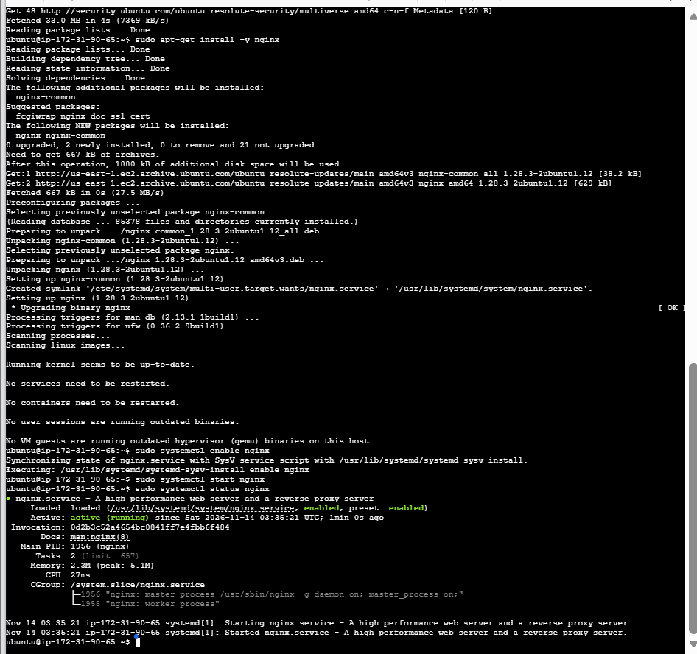  Figure 1: Nginx installation and service status showing active (running). | 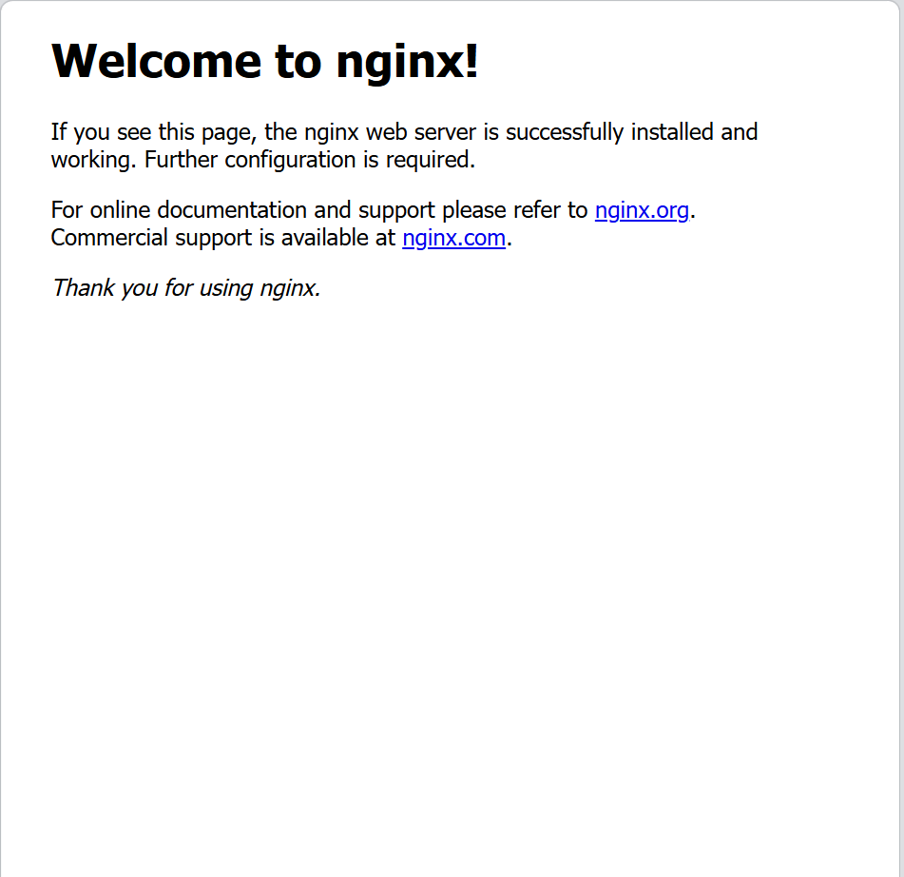  Figure 2: Default Nginx welcome page opened using the EC2 public IPv4 address.
Result:
Thus, an Ubuntu EC2 instance was successfully launched on AWS, the required SSH and HTTP inbound rules were configured, and the Nginx web server was installed and started. The default Nginx webpage was accessed successfully through the public IPv4 address.
Conclusion:
This experiment demonstrated the basic process of provisioning a cloud virtual machine using Amazon EC2, connecting to an Ubuntu server, installing a web server through Linux commands, configuring network access with a security group, and verifying a hosted page from a client browser.

